**Activity/Event Report**

1. **Name of the Activity/Event :** Dare 2 Pitch
2. **Activity/Event Venue & Date :** Seminar hall,New building:09-04-2022
3. **Nature of Participants. :** FCRIT & other college students
4. **Number of Participants :** 30
5. **Student Coordinator :** Ms. Lisha Kothari
6. **Staff Coordinator :** prof. Trupti Lotlikar
7. **Brief Summary of the Activity/Event :**
8. **Objectives :** 1. Students will get to know how to pitch.

2. Students will learn important business skills leadership,

time management, financial planning, negotiation,

research etc.

1. **Outcomes :**  1.Students were able to demonstrate their knowledge and

and understanding.

2. Students gained valuable insights which helped them

improve their critical thinking ability.

3.Students learned to present their thoughts and test their

soft skills.

1. **Meeting Link/Details :** 1st floor Seminar hall, new building.

1. **Activity / Event Photograph :** 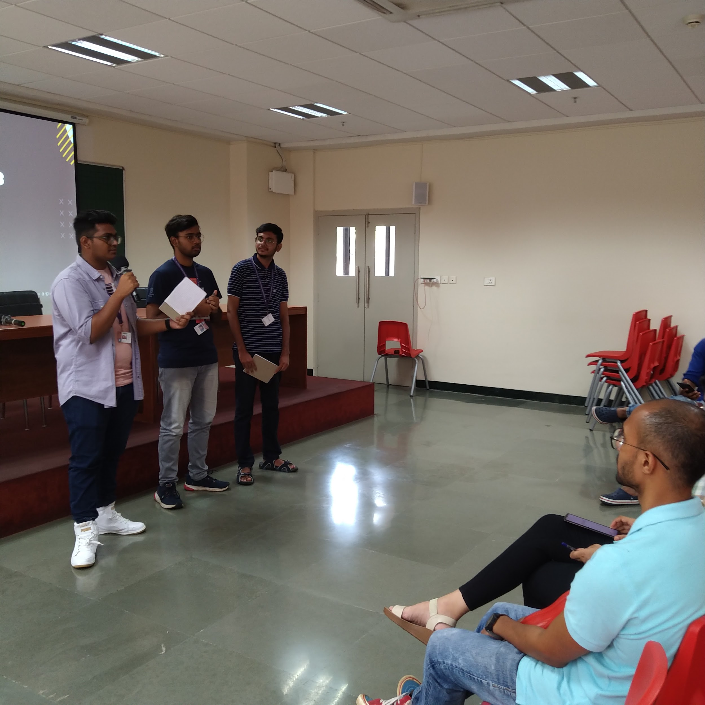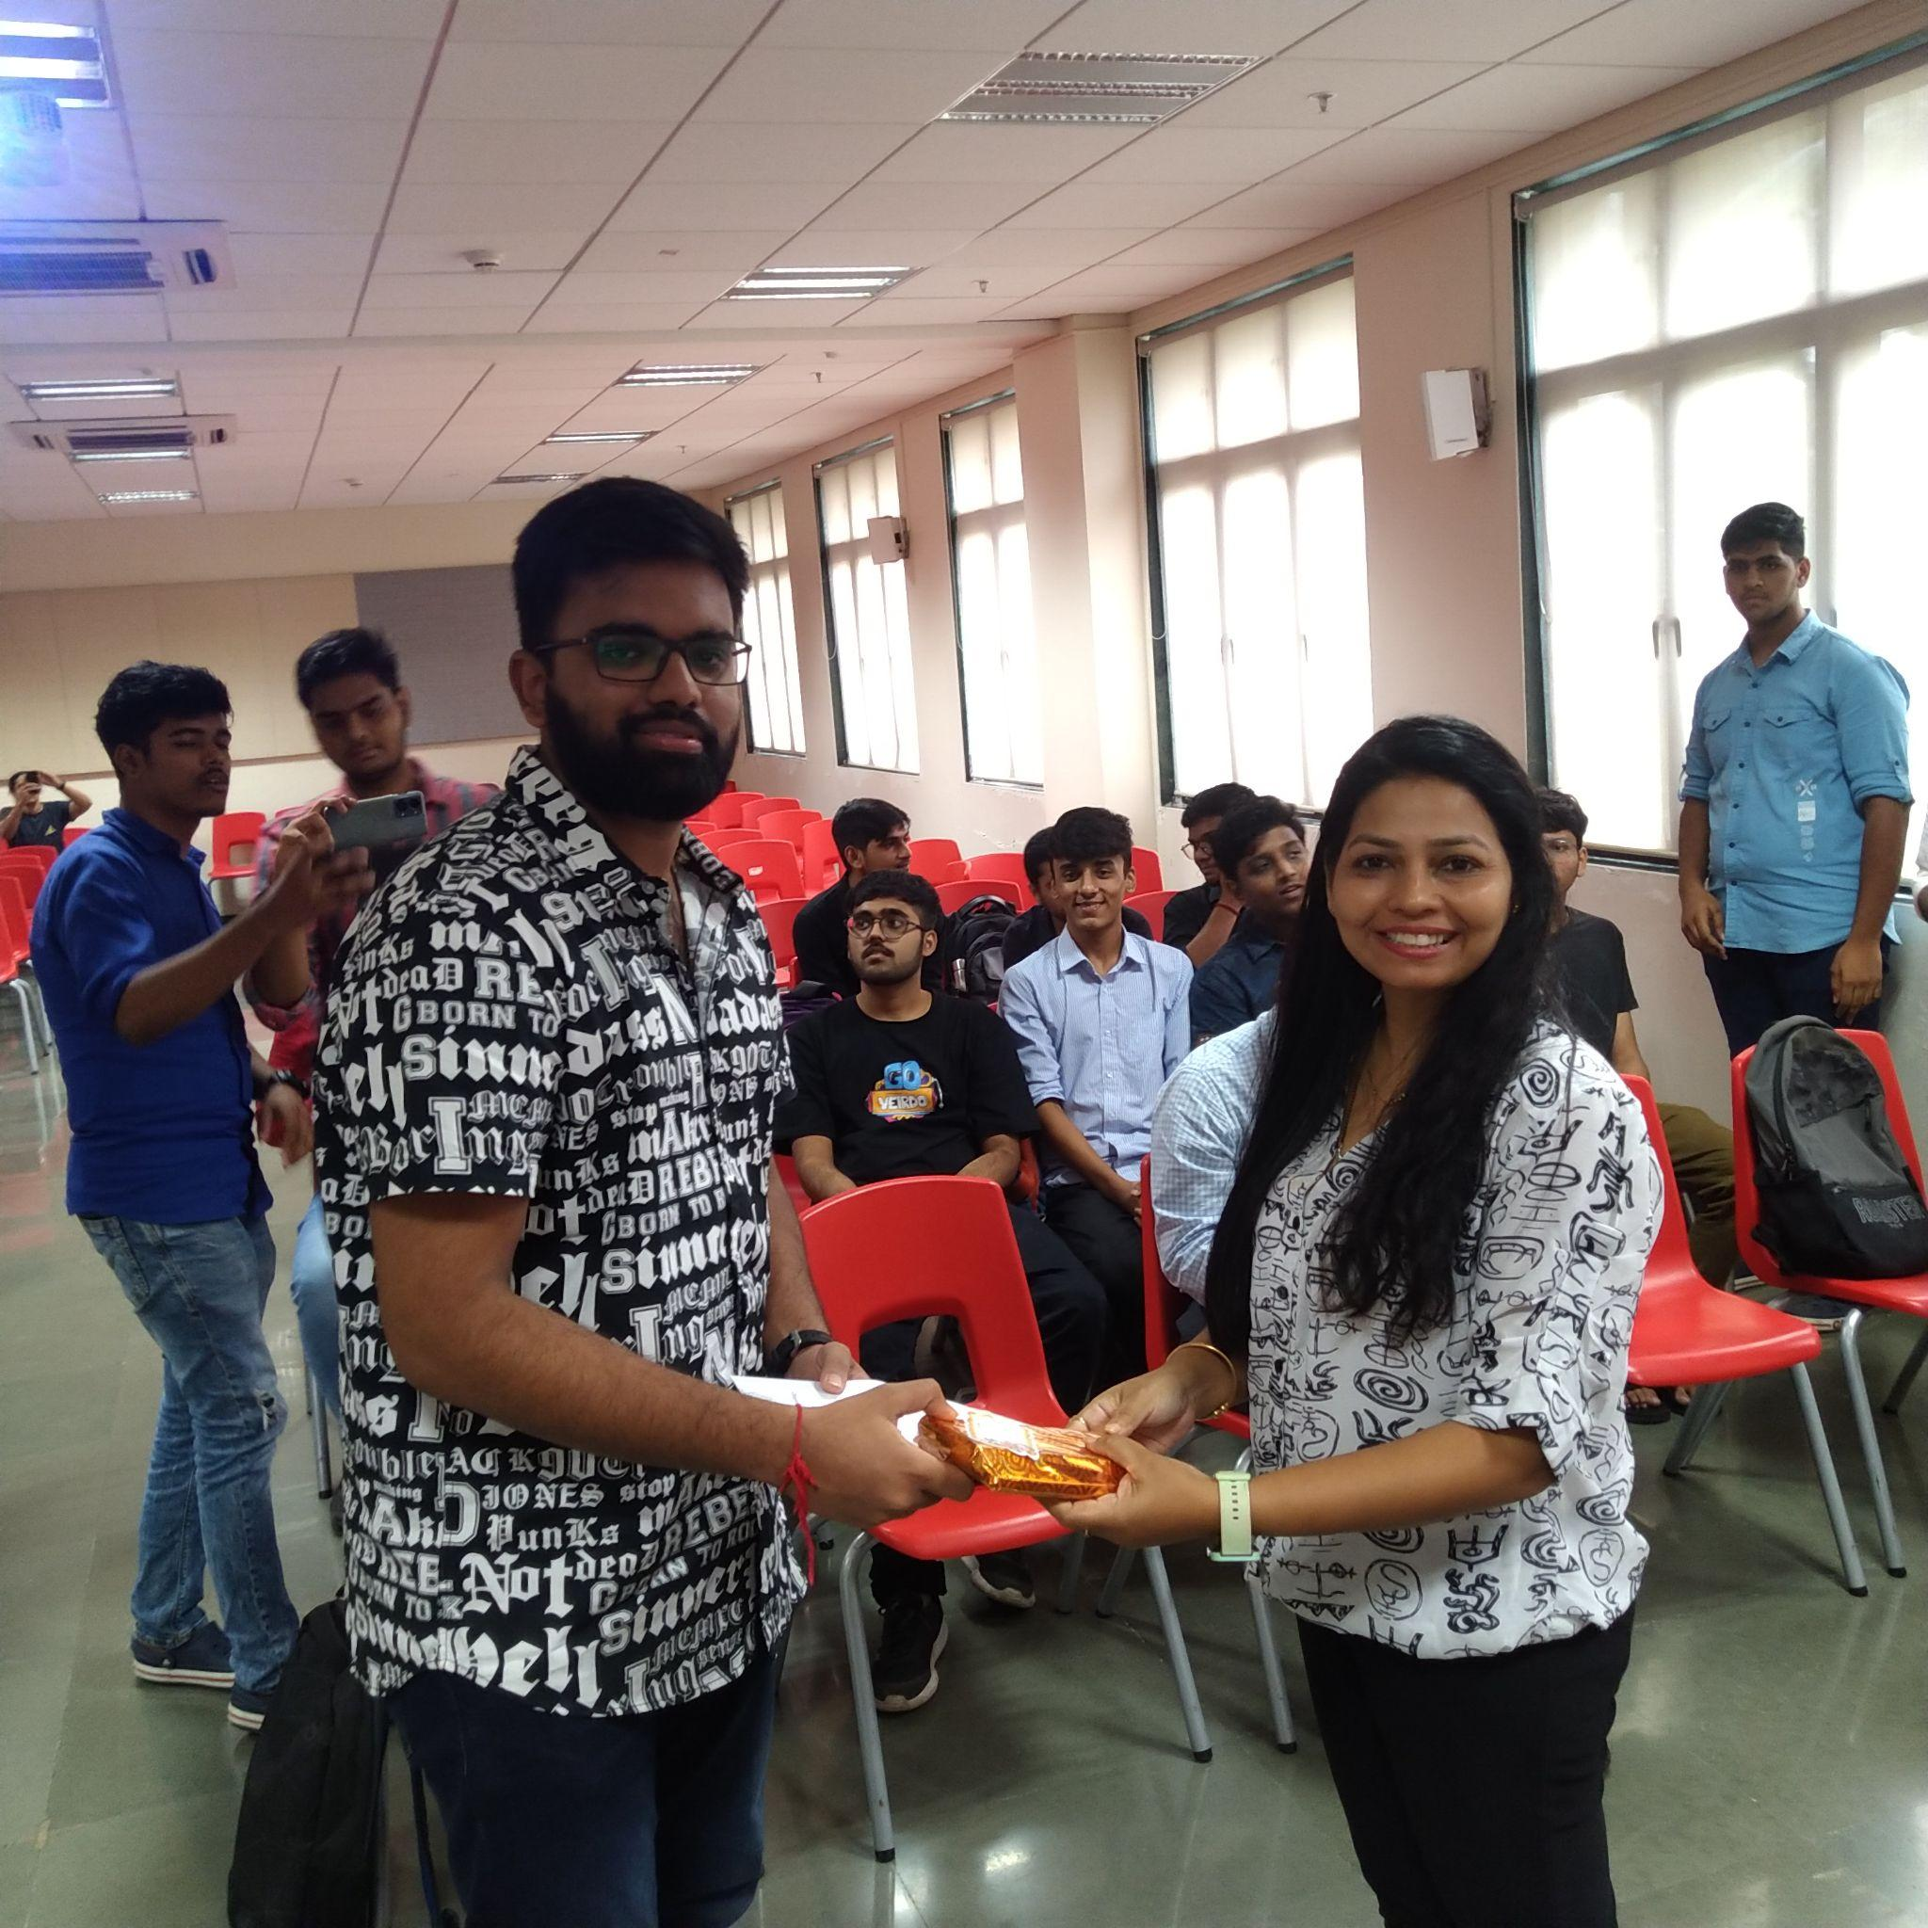



**E-Cell Coordinator**